RESPONSE SURFACE MODEL OF ECO-EFFICIENCY INDEX FOR GREEN REINFORCED CONCRETE RESIDENTIAL HOUSES (RSM-EERC)

Category | A  School (Primary & Secondary) |  | B  University and Technical Institutional Students |  |  |  | C  Academician / Industry/ Professional
Category |  |  |  |  |  |  | √
Category | Local |  |  |  | International
Category | √
Niche Area  (tick only one most relevant)  Specify sub-niche | Engineering, Science & Technology (ET) | Sustainable Development (SD) |  | Social Science & Entrepreneurship (SE) |  | Educational Technology & Innovation (ED) |  | Information & Digital Technology (IT)
Niche Area  (tick only one most relevant)  Specify sub-niche | √
Niche Area  (tick only one most relevant)  Specify sub-niche | Civil Engineering
Project Member(s) | Mohd Samsudin Abdul Hamid¹, Mohd², Md Rasul Mohamed Nor¹
Affiliation(s) | ¹Centre for Civil Engineering Studies, Universiti Teknologi MARA, Cawangan Pulau Pinang, Malaysia  ²Department of Civil and Environmental Engineering, Faculty of Engineering, Universiti XXX, Malaysia
Email of all participant(s) | samsudin85@uitm.edu.my,mohd@uxx.edu.my,rasul@uitm.edu.my
Correspondence | Mohd Samsudin Abdul Hamid  samsudin85@uitm.edu.my  +604-3822940 (O) / +60123456789 (HP)
Abstract  (maximum 200 words)  *The abstract shall briefly describe:  •Summary (what)  •Why and how (why and how it is invented, innovated or designed)  •Advantage/main features/uniqueness  •Impact to socio economic/socio environment  •Commercialization prospect | The concept of a sustainable environment generally refers to the development that creates a balance between the resources consumption pattern and the rate of natural resources depletion. This innovation presents an analytical study that focused on establishing a correlation of eco-efficiency index for concrete residential housing in Malaysia using statistical technique and performed response surface method. 3D model graphs were developed for structural concrete containing fly ash, and blast furnace slag (BFS), which was assigned to the structural members in a single and double story housing. The study has concluded that the correlations established between the cost and carbon emission, economic & environmental scores, and the eco-efficiency index have shown a linear trend for single story housing and a cubic for the double story housing. It is also determining that not all waste material is green material where examining the composition is important to classify its sustainable level. The model is applicable for designing sustainable reinforced concrete structure to meet Criteria 6 (Innovation) in Green Building Index.
Keywords  (maximum 5) | Economic scores; Environmental scores; Eco-efficiency index; Response Surface Methodology; Sustainability
Product description  (maximum 200 words) | RSM-EERC is a 3D-model that is representing the eco-efficiency index of reinforced concrete low-rise residential houses by using Response Surface Model. 3 main parameters innovate in this model consist of economical score, environmental score and eco-efficiency index. Analysis using 3D-model is giving further correlation of each parameter in designing sustainable reinforced concrete structure that is reflecting alternative material implementation in reinforced concrete design. Fly ash and blast furnace slag were used in this development of this model to differ the impact towards economical and environmental factor of reinforced concrete structure. Negative score shows in the model represents the propose design is not meet requirement of sustainability where positive score should be produces in both elements.
Pictures/ Schematic diagrams/ Flow Charts/Screenshots/Graphs and etc. | 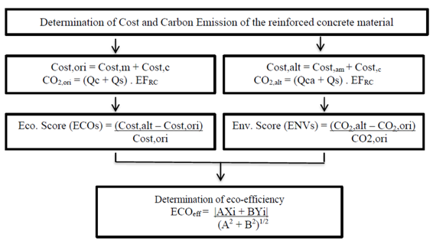  Figure 1. Determination of Eco-efficiency Index  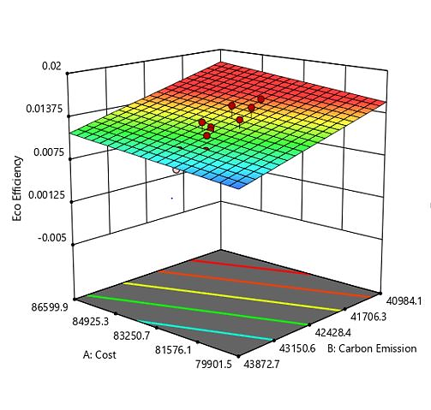  Figure 2. Response surface graph on fly ash based concrete used for single story houses.
Novelty and uniqueness | RSM-EERC is producing four (4) novelty and uniqueness. First, the novelty is about formulation of emission factor of alternative reinforced concrete (EF_{RC}), Economical Score and Environmental Score. Secondly, the prediction equation of for reinforced concrete residential houses single and double story using two alternative materials which are fly ash and blast furnace slag. Thirdly is 3D Response Surface Model of Eco-efficiency Index for reinforced concrete residential houses for single and double story. Lastly is new approach of alternative design on score evaluation for Criteria 6 in Green Building Index assessment.
Benefit to mankind | RSM-EERC is producing some advantages to different stakeholders. For structural designer, RSM-EERC is clearly give guidance in producing sustainable reinforced concrete structure that can contribute to Green Building Index score under Criteria 6 (Innovation). Towards economical and environmental impact, RSM-EERC is designed to production optimum cost of structure with minimum impact towards environment by using alternative by-product material from waste and promoting recycling. Furthermore, this innovation is proving that not all waste material is considered sustainable and green without examining the content of its composition. Some of waster material is naturally contains high embodied carbon and not contributing low carbon emission product. To the society, this innovation is helping better environment and social impact in reducing carbon emission and controlling global environmental issues especially waste management, global warming and pollution.
Potential commercialization | RSM-EERC is leading in producing guideline for Eco-efficiency Index Framework (EEIF) for Reinforced Concrete Structure Design. This guideline is applicable for structural designer to produce sustainable reinforced concrete by using alternative material in concrete technology. It is potentially use in reinforced concrete structural design for slab, beam, column and foundation with respect to different code of practices such as Eurocode, American Standards and others. Furthermore, this guideline is also secure copyright (CRLYXXX) on XX February 20XX.
Acknowledgment | The head project member acknowledges financial support from the Universiti Teknologi MARA, Cawangan Pulau Pinang for financial support in publication of this research in journal and proceeding.
Researchers Biographical Data  All team members
   | Mohd Samsudin Abdul Hamid is currently serving as senior lecturer at Centre for Civil Engineering Studies, Universiti Teknologi MARA, Cawangan Pulau Pinang and a PhD holder in Civil Engineering from Universiti Teknologi PETRONAS. He is interested in exploring knowledge specifically in structural engineering, sustainable reinforced concrete design, material engineering, structural health monitoring and earthquake engineering. Currently, he is developing structural health monitoring system for bridges in Malaysia with Jambatan Kedua Sdn. Bhd as collaborator.
   | Mohd is a Professor in XXX
   | Md Rasul Mohamed Nor is a senior lecturer at XXX

